* WHY NIR - Near Infrared - Optics?
  + Dark-color Iris: The textural details of dark-colored irides (majority of the world population) are more evident in the NIR channel than in the red, green, or blue channels.
  + Non-intrusive: NIR light cannot be perceived by the human eye. This ensures that the image acquisition process is non-intrusive, even when the eye is required to be in close proximity to the sensor and the NIR light source.
* Structure of the iris
  + The posterior layer at the back, which is two cells thick, contains heavily pigmented epithelial cells, making it impenetrable to light.
  + The muscle layer above it consists of the sphincter (circle-like) and dilator (spoke-like) muscles that contract and dilate the pupil.
  + The stromal layer, located above the muscles, is made up of collagenous connective tissue (arranged in an arch-like configuration) and blood vessels (arranged along the radial direction).
  + The anterior border layer is the foremost layer and has an increased density of chromatophores (i.e. pigment containing cells) compared to the stromal layer.

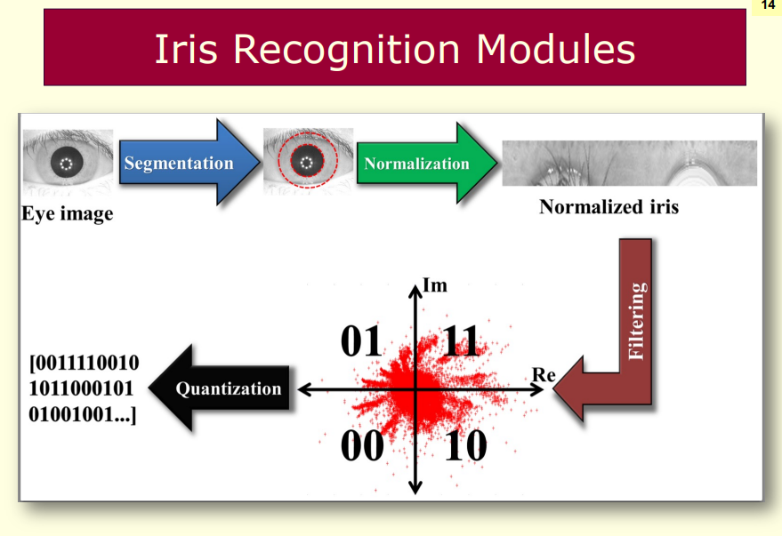

* Applications: past and present
  + Aadhaar Program - India
  + National ID Program - Indonesia
  + National Population register (“RENAPO”) - Mexico
  + CAC Program - US Department of Defense
  + Privium Program - Schiphol Airport, Netherlands
  + Border Control System - UAE
  + NEXUS and CANPASS Program - Canada
* 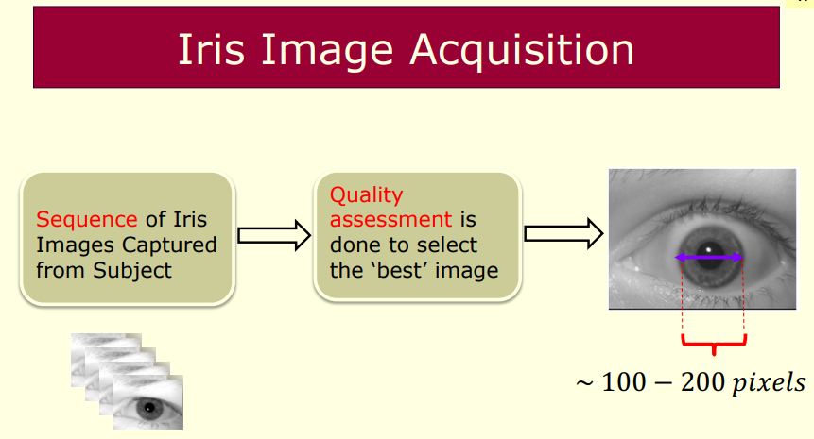
* Iris Sensors
* 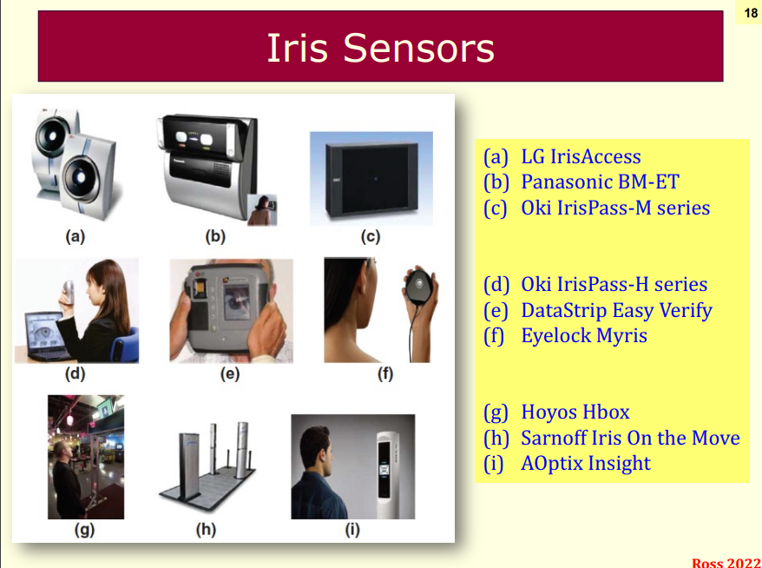
* Factors Negatively Affecting an IRIS image:
  + Occlusion
  + Motion Blue
  + Defocus
  + Non-uniform illumination
  + Poor resolution
* Quality Assessment Techniques
  + Examination of sharpness of the portion between pupil and iris from the image
  + Computation of energy of the image from high spatial frequencies using Fourier analysis
  + Quantifying the energy from 2D wavelets at local concentric iris bands
* Iris Segmentation
  + Definition: determining the pixels in an iris image that correspond to the iris
  + Challenges:
    - Iris texture is stochastic and irregular, precluding appearance-based algorithms
    - Limbus and pupillary boundaries may not be sharp
    - Eyelids and eyelashes may create irregular boundaries or be detected as spurious edges
* Integro-Differential Operator (IDO)
  + Assumptions:
    - Limbus and pupillary boundaries are circular
    - The magnitude of the limbus and pupillary boundary edge pixels is stronger than any other circular edge in the image
* 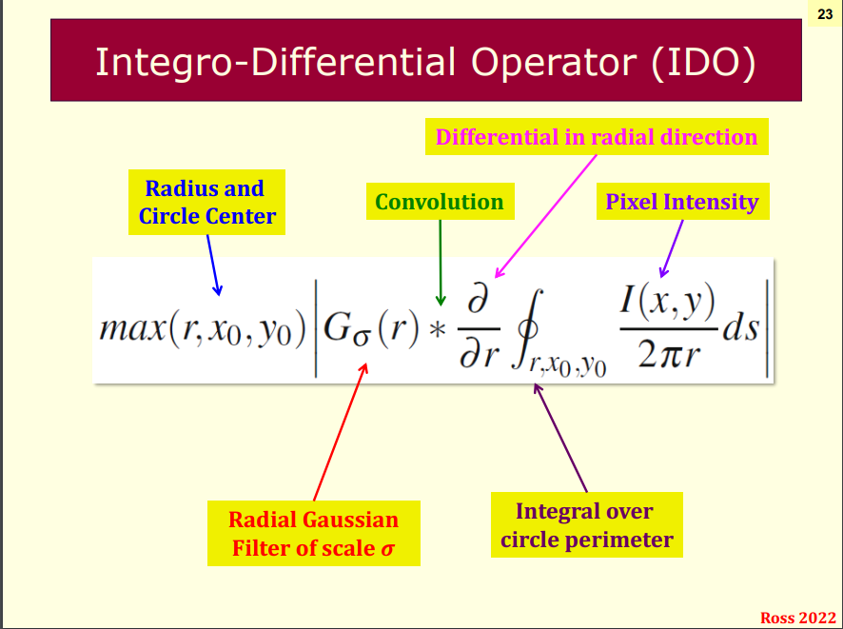
  + Summary
    - Radial Gaussian filter: convolved across image to smooth out crypts, furrows, etc.
    - Circular Integral: gradients are summed across a candidate circle’s boundary
    - Circle with max gradient sum is assumed the pupillary boundary
    - Circle with next highest gradient across vertical edges is assumed limbus boundary
* Geodesic Active Contours (GAC)
  + Assumptions
  + Limbus boundary may not be circular (e.g. due to occlusions)
  + Geodesic active contours can be used to evolve a non-circular limbus boundary approximation
  + § Summary
    - Initial contour is placed just outside pupillary boundary
    - Image gradients used to create a “stopping function” image as a stopping condition
    - Contour is evolved outward using an update function until it reaches stopping condition
    - Contour may split at local minima and later remerge, preventing strong edges in iris texture from stopping the GAC evolution
  + 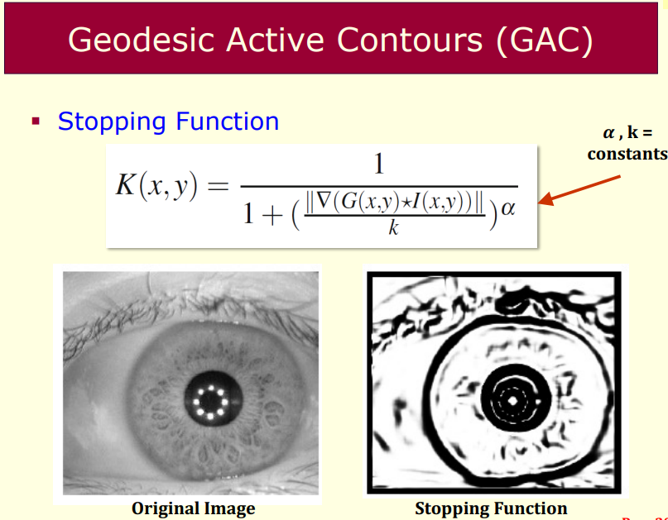
* 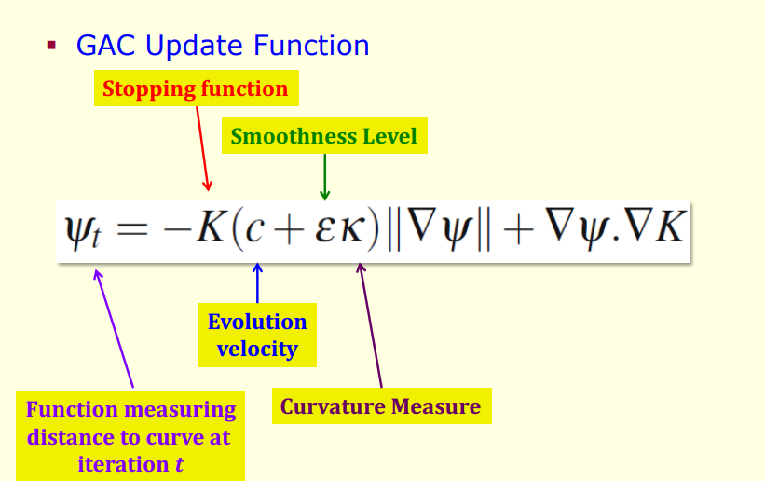
* Iris Image Enhancement
  + Normalized iris images may undergo enhancement techniques for better representation
* 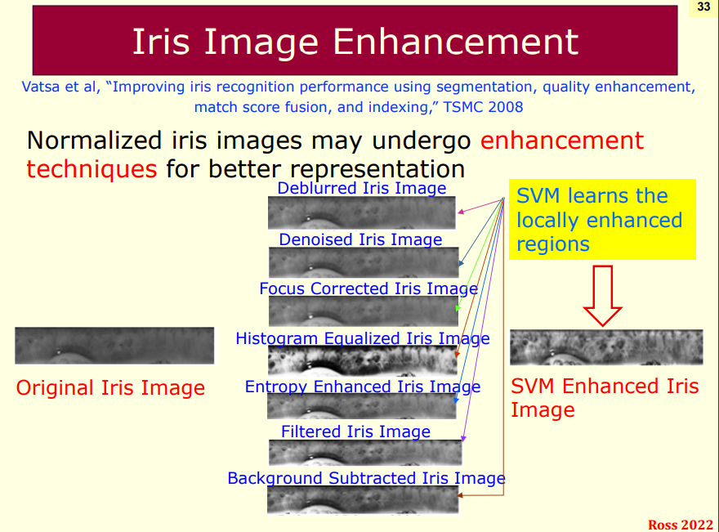
* Iris Normalization
  + Challenge with Iris
    - Size of iris and pupil varies greatly (e.g. dilation/contraction of pupil and distance to sensor)
  + Solution
    - “Normalize” the iris by unwrapping it into a rectangular region
  + Daugman’s rubber sheet model used to account for variations in iris size caused by
    - dilation and constriction of pupil
    - distance from the camera during image acquisition

